
JEANS
Element of culture

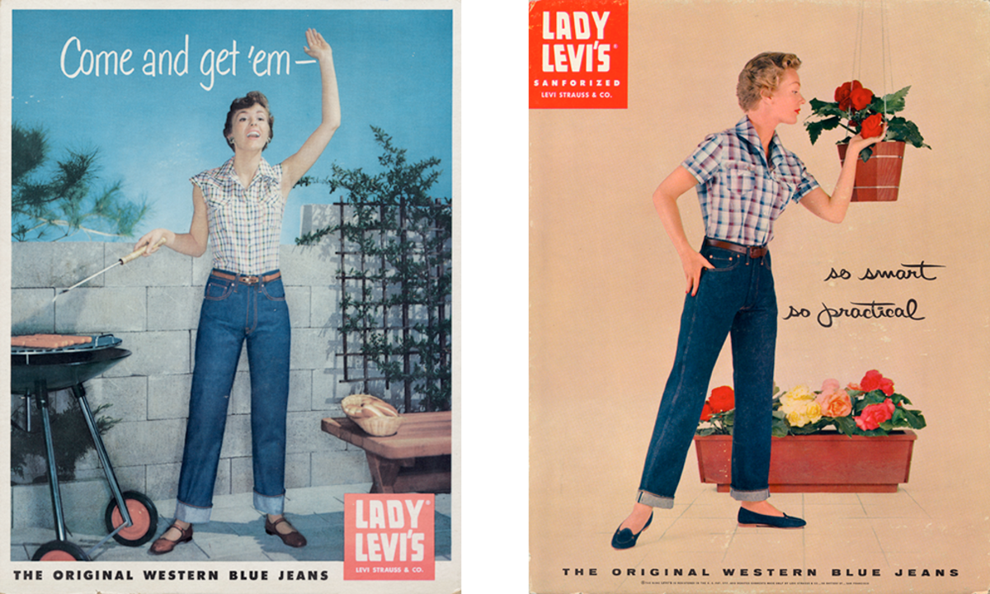

By Kate Poultney

1.0 Introduction | 1
2.0 Dispersal of jeans | 2
3.0 Diffusion of jeans | 3
3.1 Factor One – Transport | 4
3.2 Factor Two – Telecommunications | 5
4.0 Case Studies | 6
4.1 Case Study One – Embracing jeans | 6
4.2 Case Study Two – Resisting jeans | 7
5.0 Implications of the changes in the Nature and Spatial Distribution of jeans | 8
6.0 Likely future changes in the nature and spatial distribution of jeans | 9
7.0 Bibliography | 10
Table of
Contents

1.0 Introduction
Jeans are a type of trousers composed of denim or dungaree fabric. They were created in 1873 by Jacob Davis and Levi Strauss and are still worn today, though in a different context. He fashioned them out of Levi Strauss & Co. denim and strengthened them with copper rivets in the spots where pants shred the most: flies and pockets. Jeans are now worn all over the world and are considered a staple item in anyone's closet.

2.0 Dispersal of Jeans
Jeans have been dispersed all over the word through a variety of different mediums. Whether it being transport or telecommunication advancements, they have found a way into the wardrobes of so many across the world. Below is a timeline explaining when each different style of jeans became most popular.
May 20, 1873 – The birth of jeans
Back in the mid-1800s waist overalls known as dungarees were the in fashion. This was because they were seen as very practical. Levi Strauss and a tailor called Jacob Davis, made blue jeans that combined metal rivets to denim trousers to make a durable uniform that could stand up to the up to the rough and tumble work of the gold rush miners. This was a time when work wear as people knew it had been completely revolutionized for the better.
1920s to 1930s – Wild, Wild, Western
Jeans as work wear continued throughout the 1920s and 1930s, and were especially popular among in the American west amongst the miners, cowboys and labourers. Once Hollywood took this trend to the silver screen with its western style films jeans began to enter mainstream culture. Levi’s became the first item of clothing to have a designer label of jeans. After this, vogue featured its first model of denim on the cover of one of their magazines, hinting that jeans could perhaps be more than just work wear and in fact a fashion statement.
1950s – Cool blue
In the 1950s, jeans were a symbol of "cool." As they shook up the squares in their flicks, pop culture bad guys like James Dean and Marlon Brando popularised cuffed, boxy denim fashions. However some rebellious teenagers grabbed hold of this fashionable anti-establishment emblem. Following this, some school boards enacted policies prohibiting kids from wearing jeans as they thought that they were too “anti-establishment”.
1960s – Flower Power
The 1960s counterculture anthem was "peace, love, and bellbottoms." The casual blue jean (particularly bellbottoms and low-rise hip-huggers) was welcomed by the youthful, free-love movement as a symbol of liberation from more structured clothing as well as a source of creative self-expression. During this time, double denim and jean jackets made their first appearance as a fashion fad. If you embellished your jeans, it was as if you were rewarded with bonus points. Patches and embroidery were also quite popular choices of embellishments.
1970s – Americana
The 1960s' rebellious attitude spilt over into the 1970s, a decade that came to represent a new, wholesome, all-American sexuality. Cool-girls of the day, such as Farrah Fawcett from Charlie's Angels and model Lauren Hutton, epitomised this. Slim-fitting, straight-leg jeans, as well as denim skirts and vests, were popular fashion pieces as silhouettes shrank. At the end of the decade and into the next, barely-there cut-off shorts, were inspired by Catherine Bach's character in the iconic TV series The Dukes of Hazzard, became a big fashion trend.
1980s – Designer denim
Designer denim was fully born in the 1980s. “Nothing comes between me and my Calvin’s,” said a 15-year-old Brooke Shields in a Calvin Klein commercial, pushing denim to the forefront of every fashion designer's mind. In pop culture, designer jeans became a true status symbol, with Calvin Klein, Jordache, and Gloria Vanderbilt among the most prized by the cool kids. Stonewashed, acid-washed, and ripped jeans were all the rage, as were skinnier leg cuts tapered at the ankle.

1990s – Big and baggy
Due to the rise of grunge and hip-hop in the 1990s, denim trend shifted once more. Straight-leg jeans, sometimes shredded, sometimes not, kept things relaxed and Cobain-like. "Mom jeans," often known as high-waisted jeans with a more relaxed fit, were also popular—and have just resurfaced. Another popular trend was to cover yourself in denim. It was preferable if it was bigger and baggier. Carpenter jeans with several pockets and tabs, as well as head-to-toe denim ensembles, denim overalls, and shortalls, were all quite popular during this time.
2000s – Get low
Destiny's Child, Britney Spears, and Christina Aguilera popularised the super low-rise jean in the early 2000s. Retro Capri jeans made a comeback in the mid-to-late 2000s, while flare and bootcut types were also popular. Premium denim exploded in popularity at the turn of the century, with companies like 7 for All Mankind, Citizens of Humanity, and Hudson Jeans becoming household names practically overnight.
2010s – Skinny jeans
Around 2010, the popularity of music festivals began to rise. What was once a popular hangout for music fans has now become the go-to spot for fashion it-girls. Festival attire was born as a result of this transition in contemporary culture. Denim overalls, jumpsuits, and rompers, all influenced by vintage jean styles, have become must-have fashion pieces and concert apparel. The slim jean, however, is possibly the most notable style to emerge in the recent decade. Skinny jeans became the go-to style to wear during the week, on the weekend, and on date night as a result of advancements in denim stretch technology.
Present day – Cropped, culottes, straight, comfort
While denim trend is becoming more diverse, skinnier versions continue to reign supreme due to their ability to be dressed up or down. Still, there's a trend towards a looser fit, where comfort doesn't have to come at the expense of style (and vice versa). Wide-leg styles and sometimes cropped, as well as medium to high-waisted jeans with a straight or boot cut are on trend. Not to mention the new trend of shopping locally and responsibly by favouring smaller, independent denim brands, including eco-friendly denim lines. It's been deemed as the "feel good, look good" period.
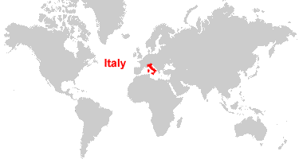
Italy is the country where Jeans were originally invented by Jacob Davis and Levi Strauss.

3.0 diffusion of jeans

3.0 Diffusion of jeans
Jeans spread throughout the "Western World" via the media, targeting specific demographics (college students, hippies, teenagers etc.) Advancements in transport and telecommunications have allowed the diffusion of jeans to be simple and easy worldwide

3.1 factor one – Transport 3.0 Diffusion of jeans

With transport advancements such as shipping (containerisation) and aeroplanes it allowed for the jeans and materials to be dispersed to factories and, stores and customers across the world. Containerisation is a system of intermodal freight cargo transport, using standard ISO containers (known as shipping containers or isotainers) that can be loaded and sealed intact onto container ships, railroad cars, planes, and trucks. This has revolutionalised to diffusion of jeans as it is a fast, easy and cost-effective way to get them from the dispatching company to the buyer.

3.2 factor two – Telecommunication

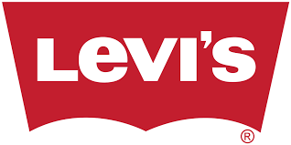
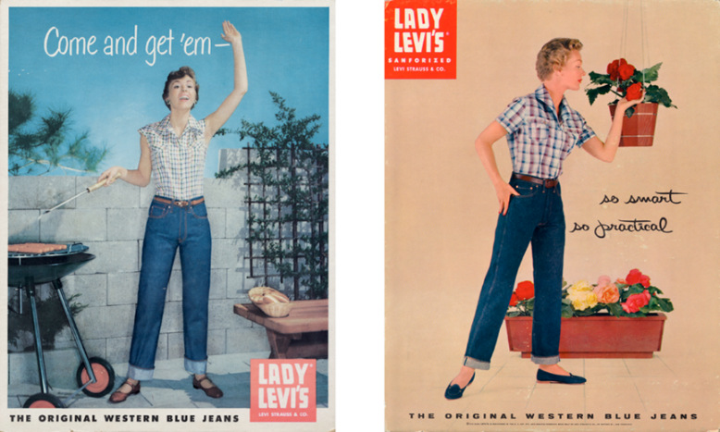
Some telecommunication advancements that have allowed jeans to be diffused worldwide are social media platforms through the invention of phones and the internet. The media also allowed brands to promote the jeans and advertise them in magazines and television advertisements. In the more recent years social media platforms such as Instagram have also made it easy to advertise the jeans to potential buyers. Transnational corporations have used telecommunication advancements to help diffuse their products also. One in particular is the company and brand called Levi’s jeans. This company was founded on May the 1st in 1853 by a man Levi Strauss. The Original headquarters was in San Francisco in California in the United States of America. Now around 132 years later there are 2,800 company-operated stores worldwide, and their products are available in more than 100 countries. Levi’s has helped with the diffusion of jeans as many countries around the world have helped to spread the name and brand to potential buyers across the world. Levi’s is a perfect example of a transnational institution aiding in the diffusion of jeans as so many countries are involved in the process of manufacturing and selling them on to other stores worldwide. Levi’s would make advertisements about their jeans and put in in magazines such as Vogue to promote their brand. Nowadays they use social media platforms such as Instagram to gain followers and hopefully sell their products. If the internet was never created not as many people would be able to easily access a pair of these brand of jeans and therefore their sales would not be

4.0 CASE STUDIES
The case studies focused on in this section are the ways in which people and places have resisted to and embraced jeans.
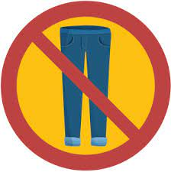
4.1 Case Study One – resisting jeans
Although jeans are extremely popular over the world and are worn by billions of people there are some places where jeans have been resisted, and some events where it is considered rude an inappropriate to wear them to.
Wearing blue jeans is illegal in North Korea and is therefore an example of a country that has resisted jeans. North and South Korea declared wearing blue jeans as illegal as it symbolises American imperialism, which the East Asian nation terms as its ‘enemy’. North Korea’s supreme leader, Kim Jong-un believes that wearing jeans are also a symbol of the capitalistic lifestyle and that is why they are not permitted to be worn. Capitalist culture promotes the accumulation of capital and the sale of commodities, where individuals are primarily defined by their relationship to business and the market. Elements of capitalist culture include the mindset of business and corporate culture, consumerism and working-class culture. Kim Jong-un believes that capitalism is undermining his power and that is why he will not have any part of it. This is clearly about a lot more than just wearing jeans but just one example of how two cultures and their lifestyles can clash leading to the banning of many things.
The founder of North Korea is called Kim II Sung. He was born in the year 1912. From the year of his birthday, North Korea counts its new year. People wearing blue jeans are banned in North Korea. Although tourists are allowed to wear blue jeans, you must wear pants of another colour before going to the Memorial Hall of Kim II Sung and Kim Jong II. In North Korea, taking photographs of poor people is a legal offence. North Korea believes that this tarnishes the image of the country.
The consequences in these two countries for wearing jeans could go as far as imprisonment if the rules are not followed.
There are also some places and events where it is considered rude or inappropriate to wear jeans these being: to a wedding, to a baptism, bat mitzvah, to a job interview, at a cocktail event, to the theatre or a show and to a court date.
4.2 Case Study Two – embracing jeans
Jeans have been embraced all over the world and now are considered to be a staple item of clothing in the average person’s wardrobe. It's impossible to find a clothing that is as generally accepted, worn, and adored around the globe as jeans. The iconic symbol of the American West has become a wardrobe standard all around the world. Cowboys, supermodels, farmers, presidents, and housewives all wear them. If you ask any group of people why they wear jeans, you'll hear a variety of responses. For some, they're convenient, long-lasting, and stylish.
The reason for their success has as much to do with their cultural meaning as their physical construction. For Americans, jeans are a symbol because everyone wears them and because they are an expression of a “relaxed” culture. For Koreans, the most common answer was that jeans express the youth/student culture. In both instances, jeans communicate a particular meaning for the wearer within her or his own cultural milieu.
They were first designed as workwear for labourers on the farms and mines of America's Western states in the late 19th Century and now look how far they have come. They can be worn to express yourself and your style. You are unlimited with the styles you can wear and that is one of the reasons as to why they are so popular.
Jeans were first embraced by workers, then cowboys and once they were bought on to the film scene fashion brands began to alter the designs to sell them to the general public.
Jeans succeeded because they were able to change with the times. Jeans turned from a type of clothing intended for manual labouring white men into a staple for many kinds of people. In a sense, jeans helped bring times of American differences into a more integrated society and culture.
They have been embraced by all people from different cultures through many ways. In recent years social media and advertising have helped people embrace them as they can see what’s the new ‘fashion’ and decide if they want to follow these new trends.
5.0 Changes in the Nature and Spatial Distribution of jeans
Some of the changes in the nature of jeans are:
- The market value for denim fabric was 21.8 billion U.S. dollars in 2020 and was expected to increase to over 26 billion U.S. dollars by 2026.
- The retail sales of denim or blue jeans is by far the most valuable channel in the denim industry.
- Jeans were first created by Levi Strauss and Jacob Davis.
- They were first invented for miners to wear as they were durable to the conditions they were under.
- The retail sales value is projected to reach at about 71.8 billion U.S dollars by 2027.
- The global denim jeans market was forecast to be worth around 87.4 billion U.S dollars that year.
- The most popular style of jeans in 2021 are boot-cut jeans.
- The most expensive pair of blue jeans were sold for $250,000.
- The most popular brands for teenagers are Abrand, LEE, and Rolla’s.
- Different age groups typically wear different styles of jeans. Older people typically wear darker blue coloured jeans with a tighter fit, however younger people wear more white or light washed jeans with a more baggy fit.

The spatial distribution of jeans has also changed some interesting points being:
- Jeans were first invented in France and they are now made in countries such as China, Japan and Italy.
- Technological advancements have made jeans accessible online all over the world.
- Egypt is the leading importer of denim for jeans made from at least 85% cotton.
- In 2020 China was the leading exporter of denim fabric worldwide, with exports valuing approximately 436.94 million U.S. dollars.
- North America accounts for 39% of global purchases for jeans, followed by Western Europe at 20%, Japan and Korea at 10% and the rest of the world at 31%.
- At a more local scale In Australia jeans are mainly distributed in large shopping centres to clothing outlet stores, and even more locally in the town of Narrogin Parry’s and JD lifestyle are two stores where you can purchase jeans.

6.0 Likely future changes in the nature and spatial distribution of Jeans
Nature- Denim designers were exploring the entire spectrum of possibilities for 2021. Whether it's loose fits, high waists, workwear-inspired designs, 80s vintage looks, or unbleached white colours, next year's denim trends are predicted to be diverse and impossible to fit into pre-made patterns. One idea, though, is gaining traction. The importance of sustainability will grow much greater. Whether it's during the denim manufacturing process or the design process. Patchwork, reworked denim, and the usage of deadstock are all predicted to become commonplace. Two high up stakeholders for the denim industry told an article about their predictions for jeans in 2021 and in the future:
Patrick Stupp, owner of Rich and Royal believes “For washes, the vintage look sets the tone. The ’80's are back with a salt and pepper look, light acid washes and a used look with bumped edges or fringed hems. The trend is going back to comfort stretch with very little elastane and even rigid denim, without any elastane at all.”
Vivian Rivetti, vice president of the global design, Wrangler exclaims that “2021 signifies the convergence of heritage and advancement, as we take inspiration from classic favourites while enhancing new and existing styles with added comfort and performance. We’ll introduce new men’s and women’s heritage fit portfolios based on our original jean styles. The chino is a key fit trend inspired by original workwear from Casey Jones Co. Acquired by Wrangler’s predecessor company, Blue Bell, in 1943.”
The nature of jeans is predicted to change to become more environmentally friendly. Typically, unsafe amounts of toxic metals like mercury, lead, and copper have been found in the water, which residents rely on for drinking and bathing. All in all, producing a single pair of jeans requires an immense amount of water and energy and creates significant pollution. One must make sustainable choices while purchasing denims such as go for organic cotton, natural dyes, rivets, and buttons made from natural or recycled materials. Avoid washes that require harsh chemicals like distressed, stonewashed, bleached jeans. Always buy classic styles that will remain in fashion. People are now looking to buy more eco/environmentally friendly jeans to help do their part to save the Earth.
Spatial distribution- In 2020 the worldwide leading importers of denim fabric used in the manufacturing of jeans were China at 436.94 million U.S dollars, Pakistan at 388.25 U.S dollars , India at 211.49 U.S dollars and Egypt at 90.45 U.S dollars. Statistics also show China is currently the leading exporter of denim fabric worldwide, with exports valuing approximately 436.94 million U.S. dollars. China has long been the leading manufacturer of denim in terms of volume, and when it comes to getting denim apparel to the United States, the Asian powerhouse is still the largest supplier—though its share continues to slide as Mexico closes the gap between its own second place spot and China's lead. Around two thirds of the world’s supply of denim jeans are made in China in a city called Xintang. China distributes the jeans and denim all over the world to businesses and manufacturing companies.
The best quality denim also comes from countries such as: Brazil Turkey, Pakistan, Italy, Bangladesh, China, Japan, and Sri Lanka. With transport and technological advancements, it makes it easy to access jeans from all over the world therefore jeans can be spatially distributed anywhere anytime.
Due to the COVID-19 pandemic that shocked the nation in 2019 it made access to goods extremely difficult and slow. It also affected the economy and sales of products. This led to many people buying local products and supporting local businesses. It was the same for jeans as in Australia people began to buy more Australian brands to boost the economy and as it was easier to access. Some popular Australian brands of jeans are: Godspeed, Outland Denim, Rolla’s, Nobody Denim, Neuw, Abrand and R.M Williams. In the near future while the pandemic is still happening people will begin to buy more of the jeans that are from their own country. This will mean the jeans are distributed on a more local scale rather than global.

7.0 Bibliography

- 11 Best Australian Denim Brands. (2021, June 4). Man of Many. https://manofmany.com/fashion/best-australian-denim-brands
- Brooke, T. (2017, December 13). No Jeans Allowed! 6 Places Where You Should Never Wear Denim. Showbiz Cheat Sheet. https://www.cheatsheet.com/gear-style/no-jeans-allowed-places-where-you-should-never-wear-denim.html/
- Elan, P. (2021, May 27). North Korea bans skinny jeans as symbol of ‘capitalistic lifestyle.’ The Guardian. https://www.theguardian.com/fashion/2021/may/26/north-korea-bans-skinny-jeans
- The History of Jeans: A Detailed Look at Denim Over the Decades. (n.d.). Byrdie. Retrieved September 21, 2021, from https://www.byrdie.com/the-history-of-jeans-2040397
- Image. (n.d.). Image. https://geology.com/world/map/map-of-italy.gif
- Jeans. (n.d.). History of Jeans. https://media-temporary.preziusercontent.com/frames-public/d/f/7/c/f/91c368c4d51bf995d73287471b4380.webp
- Sewguide. (2021, July 12). 45 Different types of Jeans {Do you have a favourite?}. Sew Guide. https://sewguide.com/different-types-of-jeans/
- Statista. (2021, June 1). Global leading exporters of denim fabric in 2020. https://www.statista.com/statistics/1010223/leading-exporters-of-denim-worldwide/
- Trends: What’s the future of denim trends? (n.d.). The-Spin-off.Com. Retrieved September 21, 2021, from https://www.the-spin-off.com/news/stories/Trends-Whats-the-future-of-denim-trends-15677
- Which Country Is the Largest Exporter of Goods in the World? (n.d.). Investopedia. Retrieved September 21, 2021, from https://www.investopedia.com/ask/answers/011915/what-country-worlds-largest-exporter-goods.asp

End of report

